39.28: 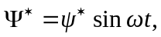 so
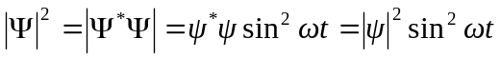.
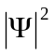 is not time-independent, so 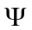is not the wavefunction for a stationary state.

